# INTRODUCTION

* 1. Overview

BUILD AN EVEN MANAGEMENT SYSTEM USING SALESFORCE

Event management is the process of creating and maintaining an event. This process spans from the very beginning of planning all the way to post-event strategizing.

Purpose

At the start, an event manager makes planning decisions, such as the time, location, and theme of their event. During an event, event managers oversee the event live and make sure things run smoothly

1. **Problem Definition & Design Thinking**
   1. Empathy Map

Paste the empathy map screenshot

* 1. Ideation & Brainstorming Map

Paste the Ideation & brainstorming map screenshot

# RESULT

* 1. Data Model:

|  |  |
| --- | --- |
| Field label | Data type |
| Enter City | Text |
| Enter Start Date | Date/Time |

|  |  |
| --- | --- |
| **Object name** | **Fields in the Object** |
| obj1-Even Management |  |
| obj2-Even Management |  |

|  |  |
| --- | --- |
| Field label | Data type |
| Event Name | Master detail relationship |
| Enter bio | Text Area |

Activity & Screenshot

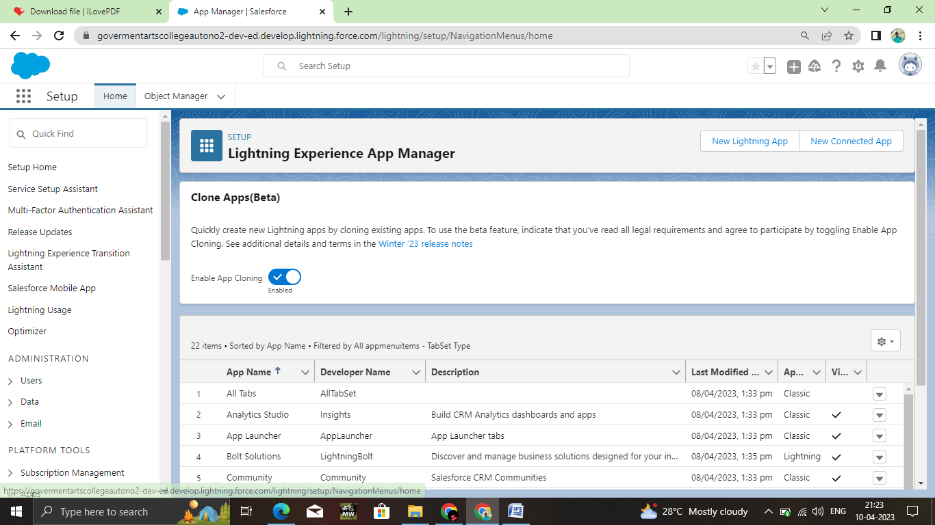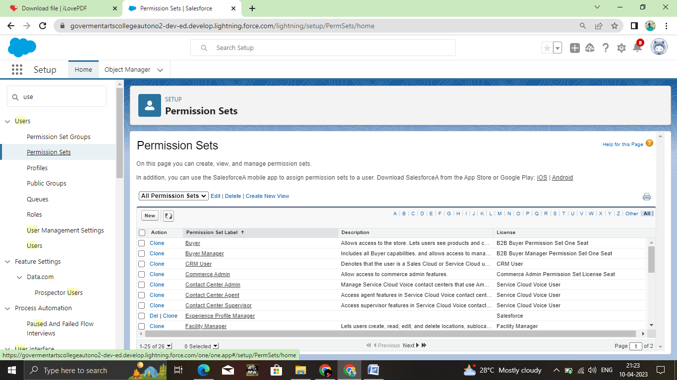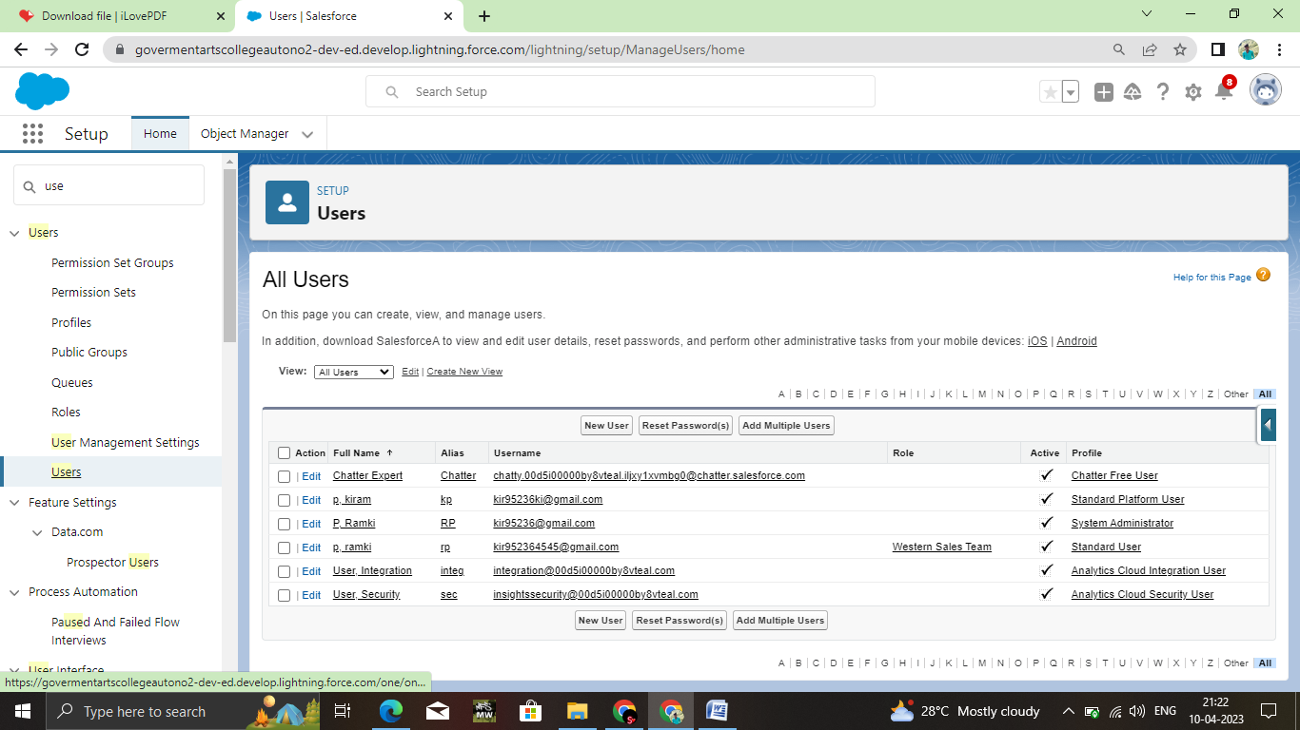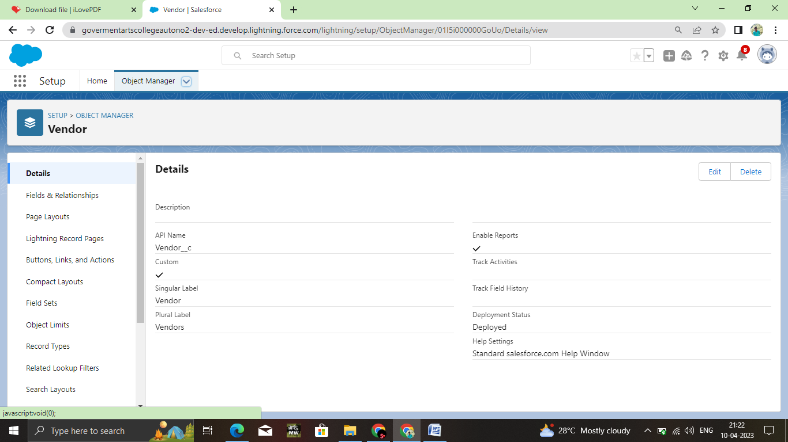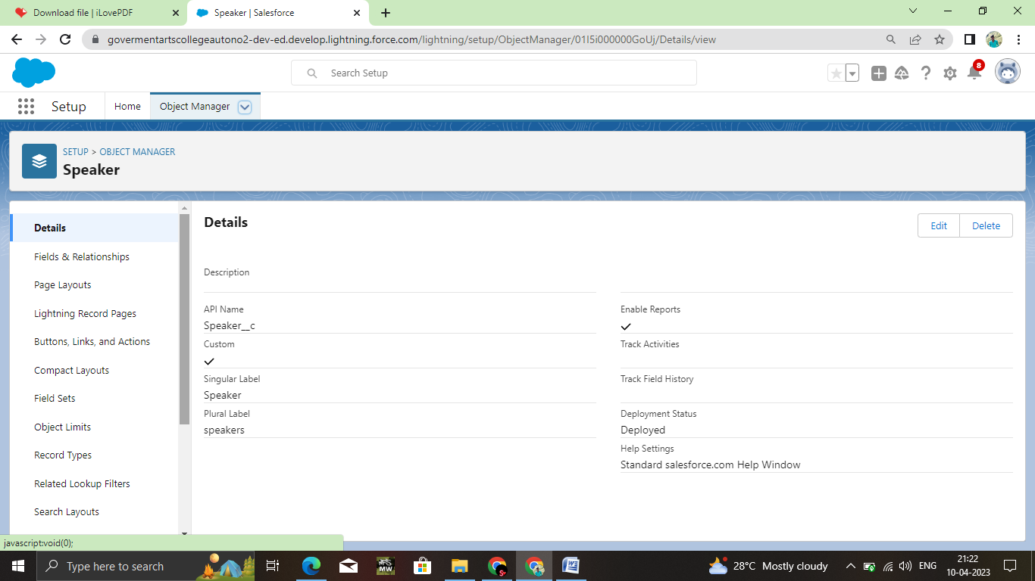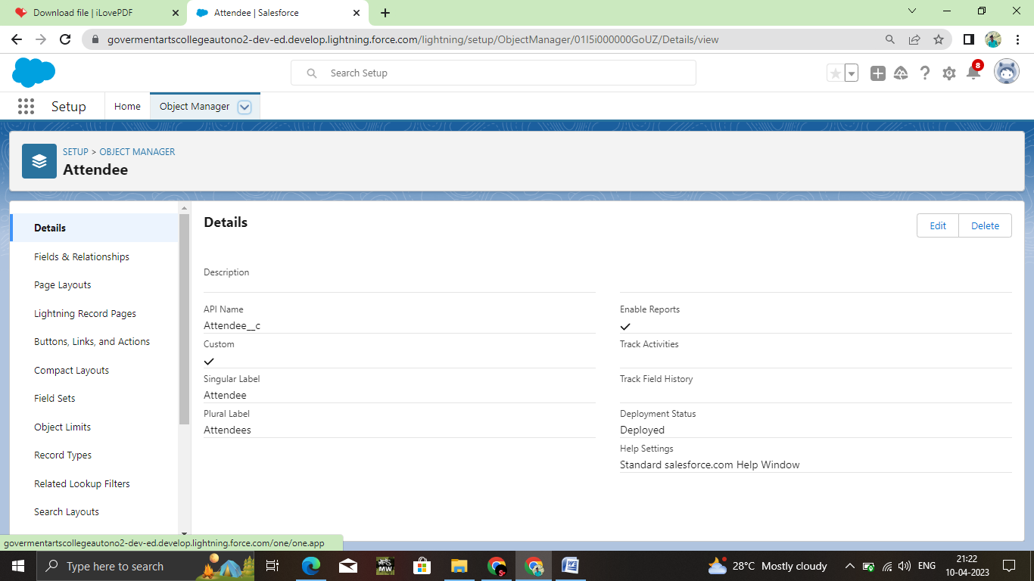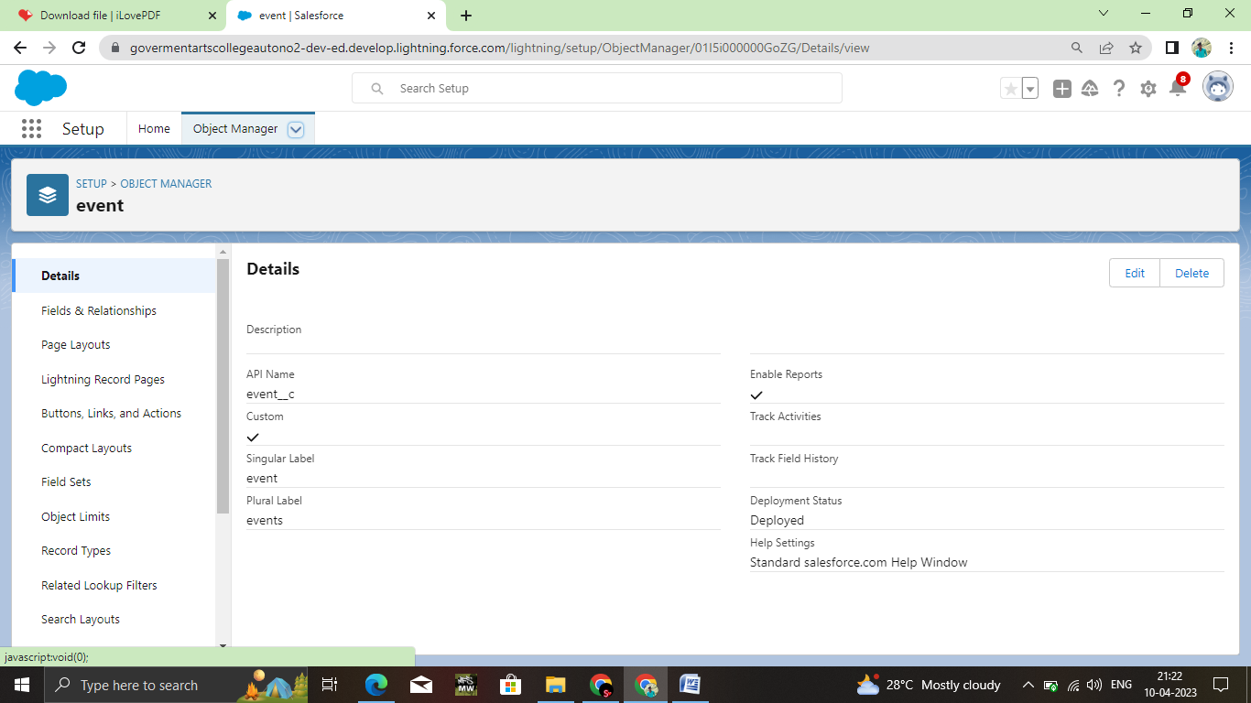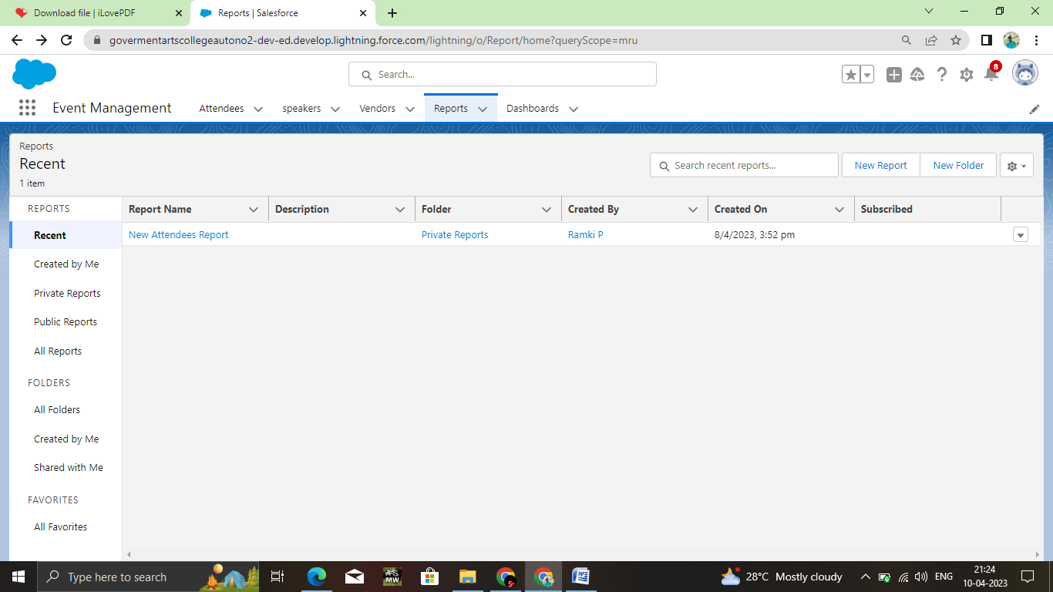

# Trailhead Profile Public URL

**Team Lead -** [**https://trailblazer.me/id/hgahlot3**](https://trailblazer.me/id/hgahlot3) **Team Member 1 -**

# Team Member 2 - Team Member 3 –

1. **ADVANTAGES & DISADVANTAGE**

* ADVANTAGES
* **Event Experts**
* **Save Time and Money**
* **Creativity**
* **Skilled Teams**
* DISADVANTAGE
* Sponsor may request changes in rule ,equipment, start time .

# APPLICATIONS

All different branches of planning go into event management, including various types of sourcing, designing, regulation checks, and on-site management. In event management, you could be in the process of creating a conference, a product launch, an internal sales kick-off, or even a wedding. Really, any event that requires considerable planning and execution is event management.

# CONCLUSION

# It provides a new edge to management industry.

# FUTURE SCOPE

Even management as a career is a multifaceted activity.

In future our project gets more importace because storing of

Informations is very essential. I so we think our project makes an impact in future.